**Programming Lab 1**

**High Performance Computing**

**ASSIGNMENT 3**

# Aim:

Write a parallel program (using OpenMp) to multiply vector and matrix.

# Objectives:

To implement program for matrix-vector multiplication using openMp.

# Theory:

Matrices and matrix operations are widely used in mathematical modeling of various processes, phenomena and systems. Matrix calculations are the basis of many scientific and engineering calculations. Computational mathematics, physics, economics are only some of the areas of their application. As the efficiency of carrying out matrix computations is highly important many standard software libraries contain procedures for various matrix operations. The amount of software for matrix processing is constantly increasing. New efficient storage structures for special type matrix (triangle, banded, sparse etc.) are being created. Highly efficient machine-dependent algorithm implementations are being developed. The theoretical research into searching faster matrix calculation method is being carried out. Being highly time consuming, matrix computations are the classical area of applying parallel computations. On the one hand, the use of highly efficient multiprocessor systems makes possible to substantially increase the complexity of the problem solved. On the other hand, matrix operations, due to their rather simple formulation, give a nice opportunity to demonstrate various techniques and methods of parallel programming.

The repetition of the same computational operations for different matrix elements is typical of different matrix calculation methods. In this case we can say that there exist data parallelism. As a result, the problem to parallelize matrix operations can be reduced in most cases to matrix distributing among the processors of the computer system. The choice of matrix distribution method determines the use of the definite parallel computation method. The availability of various data distribution schemes generates a range of parallel algorithms of matrix computations. The most general and the most widely used matrix distribution methods consist in partitioning data into stripes (vertically and horizontally) or rectangular fragments (blocks).

# Algorithm:

# Sequential Programm

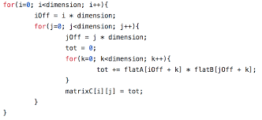

Parallel Programm

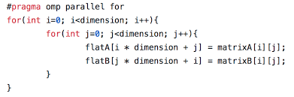

**Conclusion:**

Thus, we have implemented matrix-vector multiplication sequentially as well as parallelly.